“AI Based Virtual Desktop Partner”

## Abstract:

Artificial Intelligence is been a field in which lot of advancements have taken place. The proposed system uses some AI algorithms for the assistant to work. The assistant does all the work done by the commonly used chatbot assistants but also deploys new functionalities. The technologies being used in the system are Machine-Learning (ML), Chatbot and Neural Network .The AI based voice assistant are the programs that can recognize human voices and can respond via integrated voice system. This paper will define the working of a voice assistant, dealing with their main problems and limitations.

**Keywords:** AI, Assistant, Desktop Partner, Speech Recognition, Processor, Python.

## Introduction:

AI is the developing branch of Computer Science. A virtual assistant is known as AI assistant or digital assistant, it is an application program that understands natural language or human voice commands and completes the task of user.

We have seen lots of development in the field of technology, virtual assistant is software program that helps you to ease your day to day task such as telling todays date, opening particular app, searching specific website, playing music, showing whether forecasting and much more. The system uses Speech recognition module to understand what the user is saying. Virtual assistant are getting famous as instinctual and successful open framework between human and machine.

Virtual assistant helps to improve the customer relations as well as drastically reduce human efforts. For our project the wake up word is Assistant. Our voice assistant is designed to be used efficiently and easily to all users.

# LITERATURE SURVEY:

Virtual Assistant has a long history with the major innovations. Speech Recognition for searching and giving voice commands has become a feature on smartphone and other devices but it came long way. The base of virtual assistant is started from the Speech Recognition module:-

* 1. In the year of 1990 digital Speech Recognition module become fastest features of desktop.
  2. In the year of 1997 a software was introduced which was able to recognize and transcribe natural human speech.
  3. The first digital virtual assistant which was installed on a smartphone was Siri. It performs various activity like checking weather, making calls, etc.
  4. Amazon announced Alexa and Echo in 2014.
  5. And new AI has more new features.

# SYSTEM ARCHITECTURE:

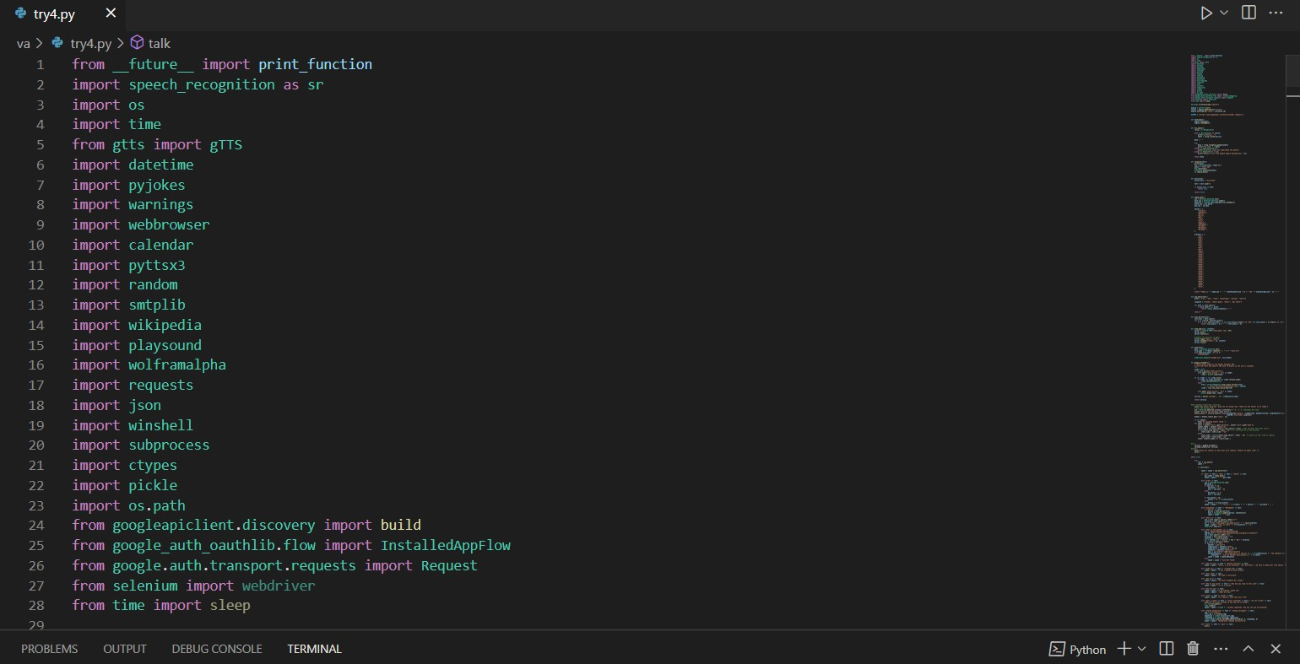

Fig.1.Packages imported

Modules Imported:-

* WolframAlpha: - It generates expert level answers of any questions given as command. It uses its own algorithms, knowledgebase and AI technology.
* pyttsx3: - It stands for text-to-speech conversion .It is one of the pythons library which converts text given as input into speech and is very easy to use.
* JSON: - JSON stands for JavaScript Object Notation. JSON is used to transfer data from a server to a web page.
* Speech recognition: - Speech recognition means that when humans are speaking, a machine understands it.
* gTTS: -Google’s text-to-speech packages, it converts your audio questions command into text.
* Datetime: - it’s a built in package in python which is used to show date and time to the user.
* Wikipedia: - As we all know that wikipedia is a huge source of knowledge or any other sources to perform a Wikipedia search we have used this package.
* webbrowser: - To perform Web Search. This comes built-in with Python.
* OS: - Operating System module in Python provides functions to the user for interacting with the OS
* Pyjokes: - It is the collection of Jokes over the Internet. We added this module to our project to add some jokes.
* Pyaudio: - PyAudio is a set of Python bindings for PortAudio, a cross-platform C++ library interfacing with audio drivers.
* Smtplib: - This python library is used for sending emails with the help of Simple Mail Transfer Protocol (SMTP).
* Requests: -This module is used to send http requests using python.

## Methodology:

The personal assistant will take input from the user with the help of microphone. The user can give command which can be related to computer commands or internet tasks like opening google, YouTube etc.. If the command given to the AI is understandable then it will provide you the output else if will return back to the user with an error message.

You can give a name to your assistant which will act as a wake keyword (“eg.Assistant”). If you give a command without the keyword “Assistant” then it will ignore your commands, until you use the word “Assistant”. Once the keyword “Assistant” is found then the command will be converted into text using the speech recognition module. The text is sent to the program as a command and it searches for the instruction in the program, If found then it gives the output in the form of speech using the speakers or it returns an error to the user and waits for a new command.

# FEATURES:

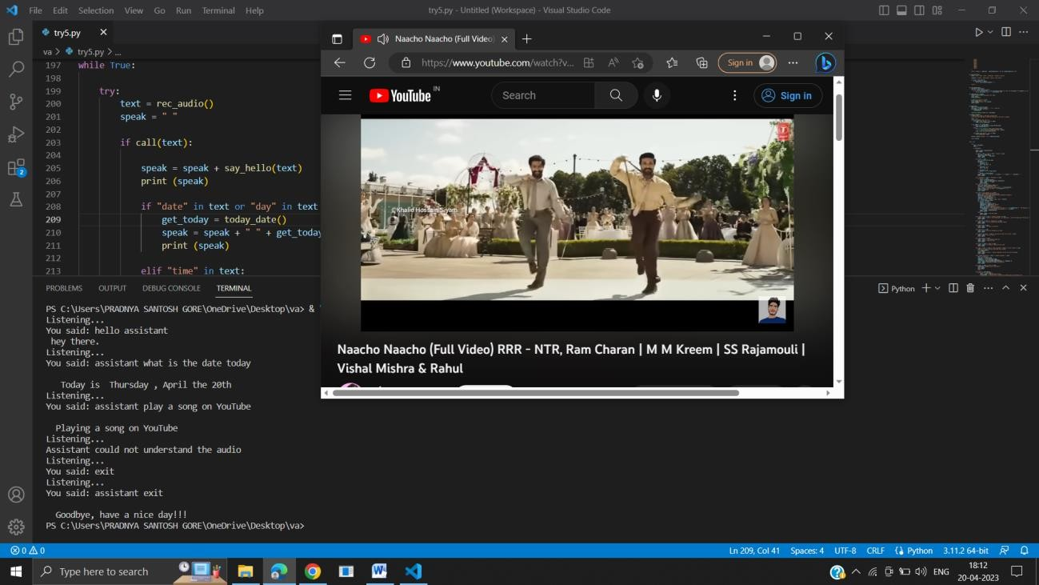

* User can give commands using voice
* PC commands like User can find any file in their computer.
* Play movies and songs downloaded in computer
* Open any application, shutdown, restart etc. the PC
* Internet commands like Search on google, open websites.
* Play YouTube videos, songs, get Wikipedia information on screen.

## Future Scope:

More features like making online orders, collecting information from calendar and taking screenshots can be added to it. Now, there is also the possibility of upgradation in our Virtual Desktop Partner. As now it is program which does not include any GUI and Application. But in the future as an additional feature of the voice assistant we can build a Graphical User Interface which can take input from the user and as well as show the result on the desktop .

## Conclusion:

This system is designed to reduce the human efforts and gain control over the device with the help of human voice. In this paper we have discussed about Virtual Assistant for Windows/Desktop using Python. As many other voice based assistant we also made a virtual assistant using python for all windows versions. Virtual Personal Assistants are effective way to manage or organize your schedule our virtual assistant will be intimate you with suggestions and taking instructions, and will know more about you. It overcomes many of the drawbacks or limitations of the existing models.